206. Reverse Linked List
Easy

Given the head of a singly linked list, reverse the list, and return the reversed list.

Example 1:
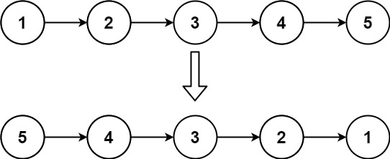
Input: head = [1,2,3,4,5]
Output: [5,4,3,2,1]
Example 2:
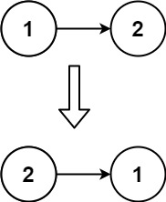
Input: head = [1,2]
Output: [2,1]
Example 3:
Input: head = []
Output: []

Constraints:
- The number of nodes in the list is the range [0, 5000].
- -5000 <= Node.val <= 5000

Follow up: A linked list can be reversed either iteratively or recursively. Could you implement both?

